


ANNUAL REPORT
(October 2020 – September 2021)

“The conservation of genetic resources in the
International Cacao Collection at CATIE (IC3)”

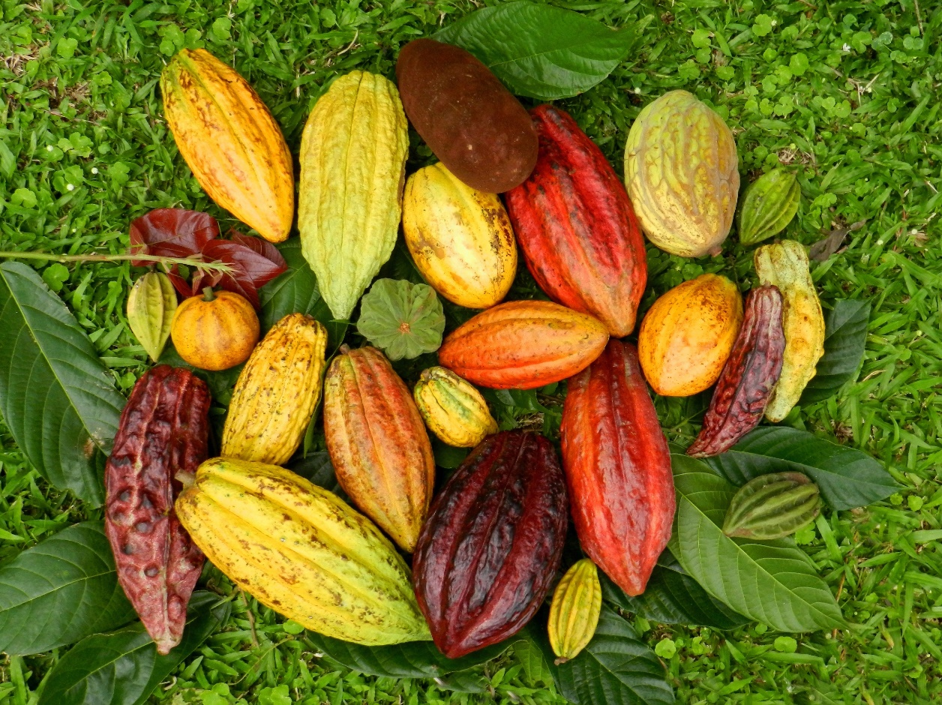

Project Cooperation between the Tropical Agricultural Research and Higher Education Center (CATIE) and the Cocoa Research Association Ltd. (CRA)

Contractor: CATIE
Rolando Cerda Bustillos (Project Contact)
Allan Mata Quirós, Dominique Dessauw, Adriana Arciniegas Leal

Project financed by: CRA Ltd.
Michelle End (Project Contact)
INTRODUCTION
The future of the cacao cultivation depends on the availability and access to the huge genetic diversity of the specie. Cacao genebanks have a very important role on this matter, due to their participation in the conservation and distribution of valuable cacao germplasm, the promotion of the chocolate industry and the development of new varieties with better characteristics, such as productivity, resistance to diseases and extreme conditions, and good quality.
The International Cacao Collection at CATIE (IC3) is one of the two most important international collections in the world. IC3 and the genebank in the University of West Indies in Trinidad and Tobago ensure global access to cacao germplasm through the conservation of their collections, both under the public domain, included in the International Treaty on Plant Genetic Resources for Food and Agriculture (ITPGRFA).
The International Cacao Collection at CATIE (IC3) was established in Cabiria, Turrialba, in 1944 and since 2001-2002, the collection was replicated in two contrasting locations in Costa Rica: at La Montaña Farm, in Turrialba (600 m.a.s.l.) and at La Lola Farm, in Matina, Limón (40 m.a.s.l.). CATIE has recently undertaken work to improve the physical and genetic characteristics of the collection, but these efforts require the commitment and support of many partners, including national and international players in public and private sectors.
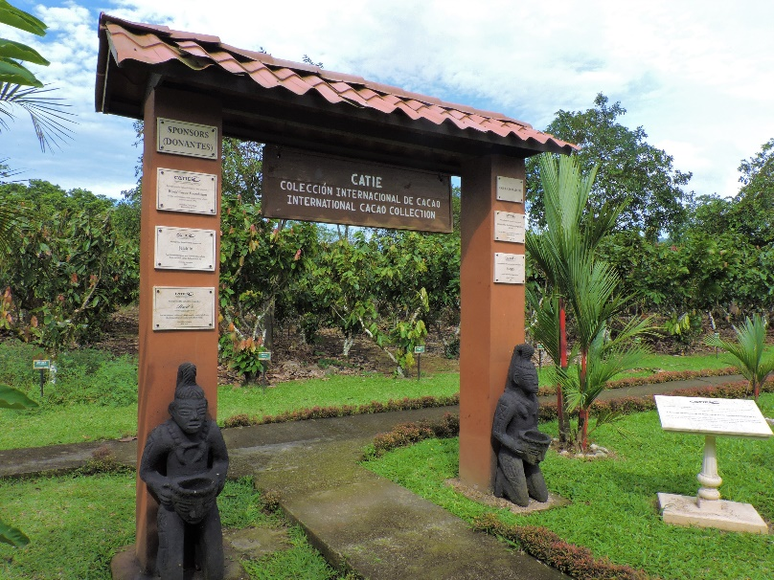
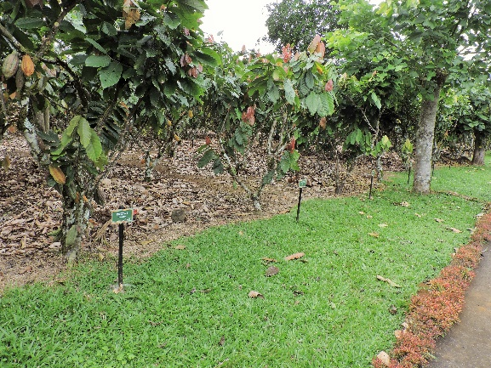
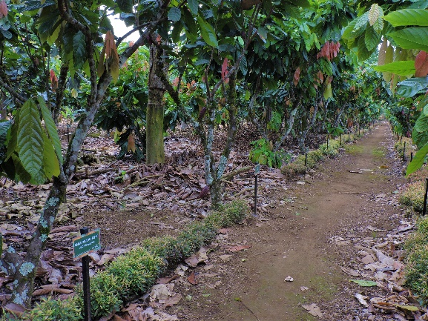
The collection has a very active role in the distribution and exchange of cacao germplasm within tropical America and with other cacao-producing regions around the world. For instance, tolerant clones to moniliasis and black pod diseases identified at CATIE are periodically transferred to the International Cocoa Quarantine Centre at the University of Reading, UK as well as to other research institutes in many countries.

DESCRIPTION OF THE COLLECTION

- Accessions and area
Currently, the collection conserves 1250 accessions, represented by three trees each. IC3 is located in La Montaña Farm, Turrialba and replicated in La Lola Farm, Matina, Limón, in the Atlantic region of Costa Rica. In both sites, it comprises 10 ha (5 ha each).
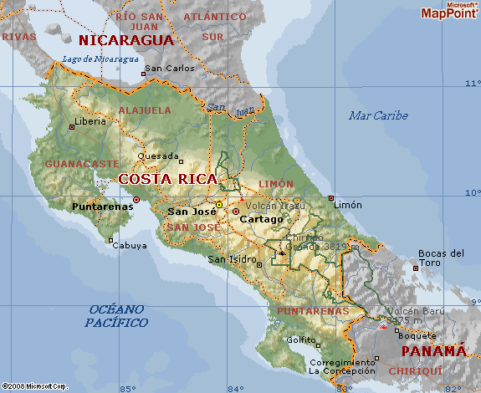
La Lola Farm
La Montaña Farm

- Accessions rehabilitated and replanted
Different factors can produce the death of some trees in the field, so, frequently, the status of the trees is reviewed, in order to avoid missing accessions. As soon as one dead tree is detected, the clone is propagated by grafting to complete the three trees per accession.
During the period, more than 300 trees belonging to 196 clones were grafted and replanted, in La Montaña as well as in La Lola. In every case when a missed tree is detected, budsticks are collected from the surviving trees and taken to the nursery for the grafting process. Labeling is very important to avoid any errors in the replanting process.
The list of clones is as follows:

5E | CRIOLLO-65 | ICS-95 T1 | MOQ-6/95 | RIM-39
AMAZ-11 | DOM-25 | ICS-95 T2 | NA-111 | RIM-41
AMAZ-15/15 | DOM-3 | IFC-5 | NA-399 | RIM-48
AMAZ-6/3 | DR-1 | IMC-14 | NA-702 | RIM-52
Amelonado-15 | EBC-10/S-401 | IMC-20 | NA-824 | RIM-68
Amelonado-17 | EEG-48 | IMC-33 | Nacional-1(A11) | RIM-76
ARF-30 | EET-395 | IMC-38 | Nacional-1(A7) | SC-13
B-7/14 | EET-400 | IMC-45 | Nacional-4(A47) | SC-20
B-7/21 | El Cuá | IMC-78 | Nacional-4(A52) | SC-64
B-9/10-25 | EQX-O | IMC-85 | OC-61 | SC-9
C-8756 | EQX-Z | INIFAP-51 | OC-77 | SCA-11
Carmelo-2 | FHIA-577 | INFAP-70 | P-22 | SGU-104
CC-107 | FILA-49 | JA-10/12 | P-7p | SGU-43
CC-11 | FILA-61 | JA-5/24 | P-8p | SGU-50
CC-236 | GDL-7 | JA-6/2 | PA-124 | SGU-60
CC-252 | GN-20 | KER-6 | PA-156 | SGU-72
CC-37 | GU 123-V | Lafi-7 | PA-169 | SGU-90
CC-44 | GU 147-N | LCTEEN-302 | PA-303 | SIAL-339
CC-57 | GU 166-N | LCTEEN-341/S-3 | PA-51 | SJ-1/19
CC-69 | GU 183-G | LECTEEN-368 | PBC-123 | SJ-1/40
CC-9 | GU 200-L | LCTEEN-37/G | Playa Alta-2 | SPA-4
CHUAO-120 | GU 221-H | LCTEEN-68 | PMCT-10 | SPEC-13845
CHUAO-24 | GU 239-H | LCTEEN-D | PMCT-11 | SPEC-194/15
CL-10/27 | GU 255-V | LF-1 | PMCT-13 | SPEC-41/6-18
CL-13/4 | Honduras-1 | LP-4/20 | PMCT-17 | TAP-10
CNS-22 | HY-2714202 | LP-4/24 | PMCT-29 | TARS-1
CRINKLE LEAF | ICS-1 | LP-4/8 | PMCT-39 | TARS-14
CRIOLLO-1 | ICS-100 | LV-17 | PMCT-45 | TARS-23
CRIOLLO-12 | ICS-12 | México-11(A1) | PMCT-49 | TARS-34
CRIOLLO-13 | ICS-134 | México-11(A2) | PMCT-50 | TRD-32
CRIOLLO-18 | ICS-137 | México-4(A4) | PMCT-53 | TSH-516
CRIOLLO-19 | ICS-27 | México-4(A5) | PMCT-98 | UF-601
CRIOLLO-22 | ICS-39 | México-7(A1) | RIM-10 | UF-667
CRIOLLO-23 | ICS-48 | México-7(A2) | RIM-100 | UF-677
CRIOLLO-28 | ICS-5 | México-7(A3) | RIM-105 | UF-700
CRIOLLO-37 | ICS-6 | ML-1/2 Peso | RIM-15 | UNAP-2
CRIOLLO-56 | ICS-61 | ML-4 | RIM-19 | VB-663
CRIOLLO-62 | ICS-68 | MO-20 | RIM-2 | YAMADA-LVD
CRIOLLO-63 | ICS-91 | MO-9 | RIM-21 | YAMADA-LVK
 |  |  |  | Yucatán

- New accessions introduced
In February 2021, A group of 20 accessions were introduced from the International Cocoa Quarantine Centre at the University of Reading. The budwood were received in good conditions and immediately grafting was undertaken. Regular observations and maintenance of the plants were made during the following 4 months in the nursery to assure the higher survival rate and establish them in the field.
Out of the 20 clones, 5 clones were unsuccessful and so they will be requested again in October 2021, when a new group of clones will be received from Reading and 7 more clones from a clonal garden of the Ministerio de Agricultura y Ganadería of Costa Rica.

Clone Name | Established in the field | Clone Name | Established in the field
AM-1/57 |  | PNG-139 | X
COCA-3348/44 |  | PNG-210 | X
CRU-104 | X | PNG-215 | X
CRU-89 | X | PNG-224 | X
EET-28 |  | PNG-336 | X
ICS-42 |  | PNG-360 | X
IMC-33 |  | SCA-10 | X
IMC-85 | X | SHRS-07 | X
LP-4/8 | X | SPEC-194/15 | X
PA-126 | X | TAP-12 | X

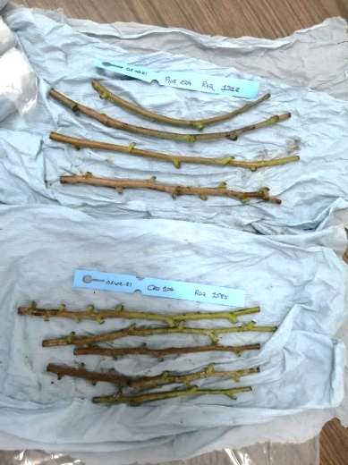
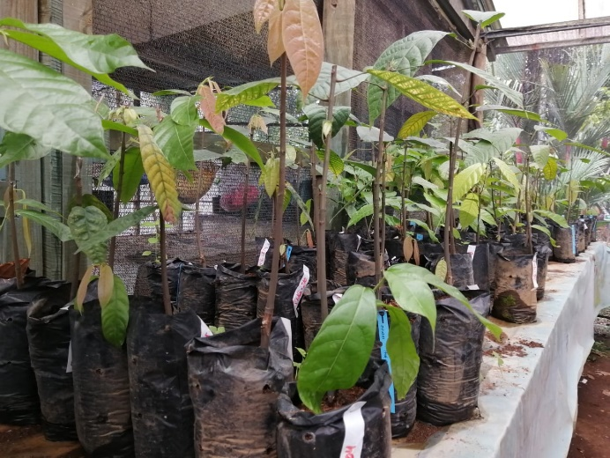

- Main activities developed

- Cacao and shade pruning
Maintenance pruning for the cacao trees and shade species is applied every 6 months in the collection during the rainy season in Turrialba and La Lola. The practice involves the elimination of horizontal branches and the ones over 3 meters. This important practice stimulates the development of new branches to maintain the health and juvenility of the trees.
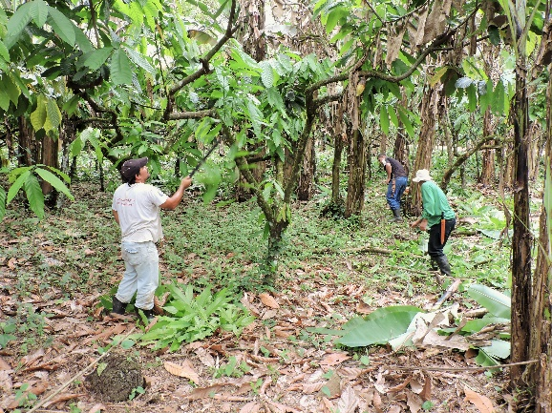
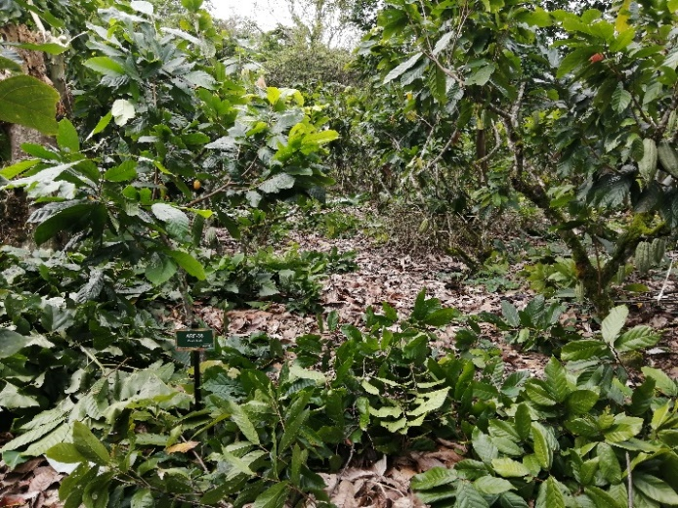
- Elimination of chupons
Chupons are eliminated every three months during the weed control application. This practice is very important, mainly in the juvenile plants established in the field.
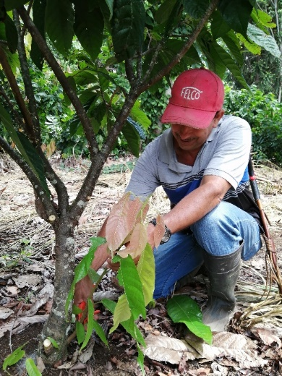

- Sampling and soil analysis
Monitoring the soil fertility is also very important to ensure good growth, productivity and health of the trees. During the period, soil samples were collected in all the plots in La Montaña Farm and sent to CATIE’s soil laboratory for the chemical analysis. Based on the results, actions were undertaken to correct any deficiencies detected.

- Fertilizer application
Fertilization with 18-5-15 (NPK) is applied in the field every three months in February, May, August and November. 150 g per tree is applied per time, to a total of 600 g/tree/year.

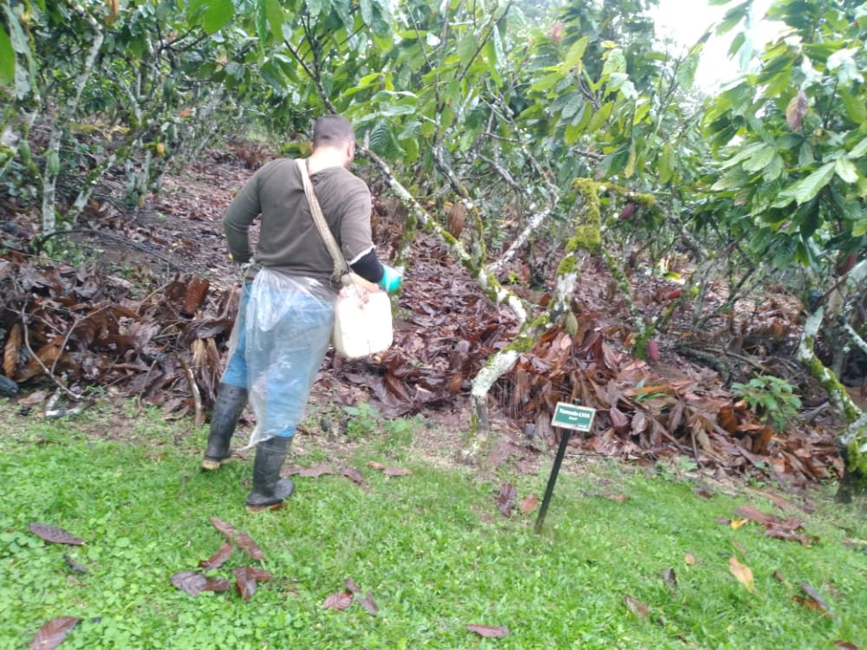
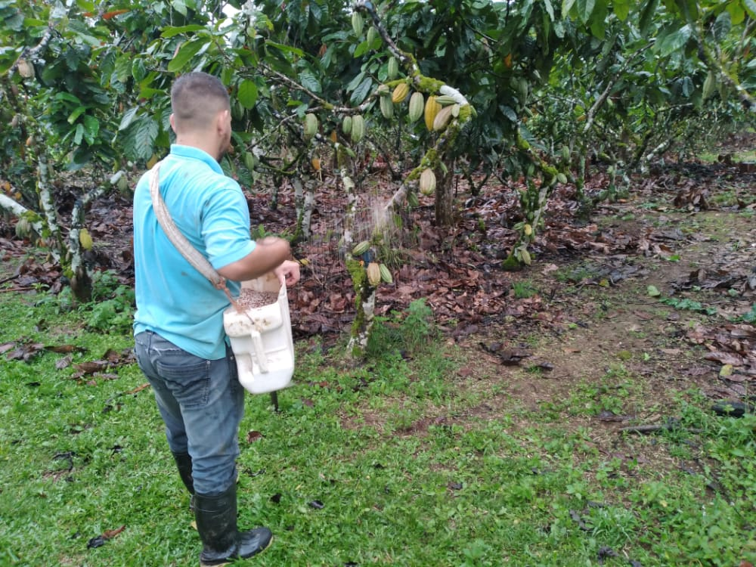

- Harvest
Harvest was done every two weeks and monthly at the end of the period when production of pods is reduced. Fresh beans were sold to local consumers, and some clones were fermented and dried in CATIE’s facilities to continue the process of evaluation of quality that CATIE regularly do to identify parameters of flavor in the accessions conserved in the genebank.

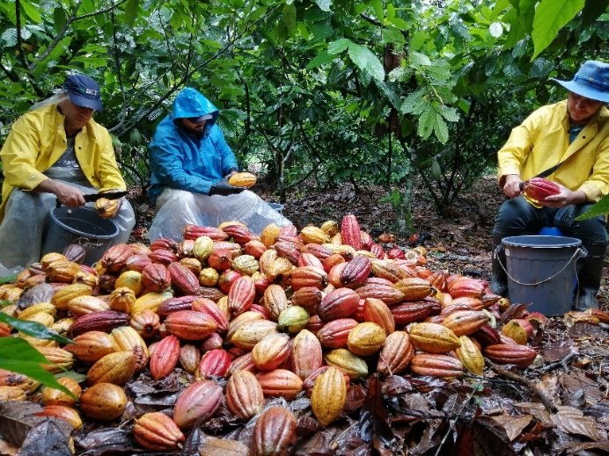

- Herbicide application
Although the weed control is done mainly manually, herbicide is used rationally, only in the plots where weeds grow faster than other plots. If necessary, herbicide is applied every 3-4 months.

- Manual weeding control
Manual control is the main way to control weeds. The weed control is usually applied every three months in all sections of the collection, especially in the gardens and areas surrounding the collection. Depending on the environmental conditions, more frequent applications are necessary.

- Elimination of disease-infected pods
Pods infected by the common diseases in the collection (Frosty Pod Rot - Moniliophthora roreri and Black Pod Rot - Phytophthora palmivora) are regularly eliminated from the collections every two weeks or every month, depending on the incidence. This practice permits a better control of the dissemination of pathogens.
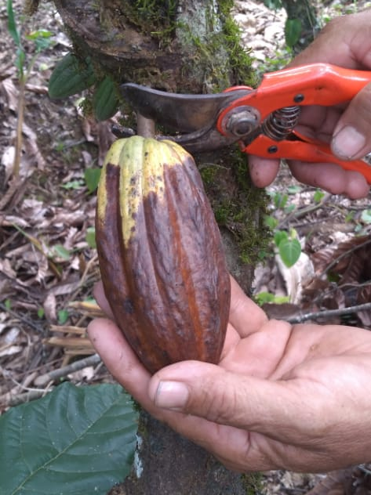

- Elimination of infected trees
“Mal de machete” caused by Ceratocystis cacaofunesta is a disease affecting some trees in the field. When a tree is detected with the disease, is eliminated and replanted. Although is not usual, a few trees infected by Rosellinia were detected in the collections some months ago and they were completely eliminated and control practices were applied to avoid dissemination of the pathogen.

- Accessions characterized
In the CATIE’s genebank, most common activities related to characterization are: Artificial inoculations to test resistance, Compatibility test and quality tests.

- Artificial inoculations
Artificial inoculations with the pathogens Moniliophthora roreri and Phytophthora palmivora are routine undertaken in the collection to identify the sources of resistance to these diseases. Many clones have been already evaluated and categorized as resistant or susceptible in different ranges.
In the last year, 1415 pods were inoculated with M. roreri in 17 events and 283 pods in 12 events with P. palmivora. The number of total trees evaluated were 511 and 138, respectively.

- Compatibility test
Self-compatibility is a character evaluated in the genebank. For this, mature flower buds are covered with a tube of glass, fixed to the tree with a rubber band. Artificial pollinations are done the next morning between 6:00 and 11:00 am, by rubbing the anthers from a male parent on the stigma of the female parent flower until pollen grains are seen to remain adhered to the stigma.
After pollinations, the flowers are again covered with the tubes and fifteen days later is determined the percentage of flower retention. When retention is ≥30%, clones are classified as self-compatible.
A group of 19 clones belonging the series ML-, RIM- and SGU- were evaluated during the last year, as follows:

México-10 | RIM -15
ML-1/2 Peso | RIM-13
ML-102 | SGU-50
ML-103 | SGU-54
ML-105 | SGU-60
ML-106 | SGU-67
ML-22 | SGU-71
ML-4 | SGU-82
ML-75 | SGU-89
P-22

- Quality test
Basic quality tests are done in the field and in the Quality Cocoa Laboratory of CATIE. After harvest, microfermentation are completed clone by clone for some 6 days and then the samples are dry under the sun. Samples are brought to the laboratory where a cut test is the first step, followed by roasting, shelling, grinding and conching.
Small samples of cocoa liquor are prepared in the laboratory and are sometimes used for organoleptic evaluations. On occasions, samples are shared with partners in the chocolate industry where chemical analyses are undertaken.
Thirty-eight clones were evaluated for regarding quality, as shown below:
ARF-1 | EET-381 | MAN-12
ARF-6 | EET-387 | MAN-15/2
BE-10 | EET-397 | México-1(A3)
Búfalo-1 | EET-408 | México-1(A4)
CC-213 | EET-45 | NA-33
CC-225 | FHIA-485 | Nacional -1(A3)
CC-235 | FHIA-707 | Nacional-1(A3)
CC-262 | ICS-1 | Nacional-2(A19)
CCN-16 | ICS-39 | Nacional-2(A25)
CRIOLLO-15 | ICS-4 | RB-46
EEG-29 | ICS-47 | SCA-9
EEG-48 | ICS-95 | TSH-516
EET-103 | LV-28

Acknowledgements
We are grateful for the support from CRA, and the contributors to its Conservation Initiative, which complements the support from CATIE, and contributions from MOCCA and the Embassy of France in Costa Rica and allows us to utilize and maintain these valuable genetic resources held in the IC3 for the service of the international community.

